**Ex. No.: 10B Roll no:231901002**

**Date: 5/4/2025**

**Aim:**

FIRST FIT

To write a C program for implementation memory allocation methods for fixed partition using

first fit.

**Algorithm:**

1. Define the max as 25.

2: Declare the variable frag[max],b[max],f[max],i,j,nb,nf,temp, highest=0, bf[max],ff[max]. 3: Get the number of blocks,files,size of the blocks using for loop.

4: In for loop check bf[j]!=1, if so temp=b[j]-f[i] 5: Check highest

**Program Code:**

#include <stdio.h> #define MAX 25

int main() { int frag[MAX], b[MAX], f[MAX], i, j, nb, nf, temp; static int bf[MAX], ff[MAX];

printf("Enter the number of blocks: "); scanf("%d", &nb); printf("Enter the number of files: "); scanf("%d", &nf);

printf("\nEnter the size of each block:\n"); for (i = 0; i < nb; i++) { printf("Block

%d: ", i + 1); scanf("%d", &b[i]);

}

printf("\nEnter the size of each file:\n"); for (i = 0; i < nf; i++) { printf("File

%d: ", i + 1); scanf("%d", &f[i]);

}

for (i = 0; i < nf; i++) { for (j

= 0; j < nb; j++) { if (bf[j] !=

1 && b[j] >= f[i]) { ff[i] = j;

frag[i] = b[j] - f[i];

bf[j] = 1; break;

}

}

}

printf("\nFile No\tFile Size\tBlock No\tBlock

Size\tFragment\n"); for (i = 0; i < nf; i++)

{ printf("%d\t%d\t\t%d\t\t%d\t\t%d\n",

i + 1, f[i], ff[i] + 1, b[ff[i]], frag[i]);

}

return 0;

}

**Sample Output:**

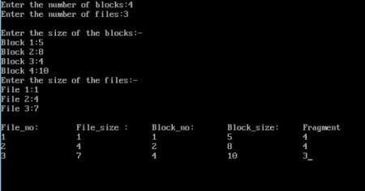

**Result:**

First Fit memory allocation technique was implemented using C